Admiral. Mohamed Braia  Vice President of Ports Affairs of Suez Canal Economic Zone (SCZONE) | 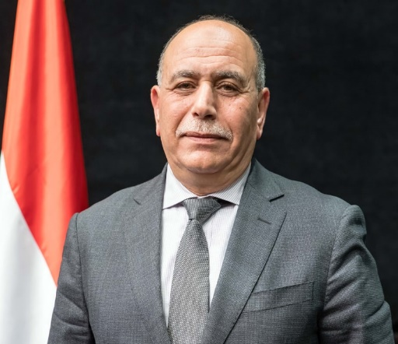

On January 2019, Admiral Mohamed Abdel-Aziz Braia appointed as Vice - Chairman of the Suez Canal Economic Zone (SCZone).
Admiral Braia graduated from Egyptian Naval Academy in 1983. He promoted to several positions, most notably, Commander of Maritime Administration and managing division, Commander of the Egyptian Navy in Saudi Arabia and Northern Naval Fleet commander.
In France 2016, Admiral Braia was the Mission Commander of Receiving and Training of the Mistral helicopter carrier “Gamal Abdel-Nasser”. He awarded medals of military duty of Frist and Second Class.
Admiral. Braia has Scientific and practical experience in the field of maritime transport, crisis management, international relation management, logistics field and general management field.

